Eventi
Use Case Specification

Submitted to:

Asst. Prof. Ma. Rowena C. Solamo
Faculty Member
Department of Computer Science
College of Engineering
University of the Philippines, Diliman

Submitted by:
Dimaano, Aaron Diego I.
Lopez, Matthew S.
Torres, Jacob Angelo V.

In partial fulfillment of academic requirements
for the course
CS 191 Software Engineering I
of the
1st Semester, AY 2015-2016
Unique Reference:
The documents are stored in https://github.com/Tom-2013-06417/CS191-192_Event_Sharing/tree/master/02-Requirements%20Engineering.
Link to this document: https://github.com/Tom-2013-06417/CS191-192_Event_Sharing/blob/master/02-Requirements%20Engineering/2.1%20-%20View%20organization%20profile.pdf.

Document Purpose:
The purpose of this document is to exhaust the step-by-step process of the Use Cases in every scenario possible.

Target Audience:
To our project client and adviser, our fellow 191 classmates, and our future selves when they need to refer back to this document.

Revision Control:

Revision Date | Person Responsible | Version  Number | Modification
09/18/15 | Dimaano, Diego  Lopez, Matthew  Torres, Jacob | 1.0 | Initial Document

Use-Case Name: View organization profile

Description: This is a fundamental operation of any Eventi user. As the search results are displayed, users have the option of viewing the organization profile handling the event. The user is redirected to the organization’s profile if requested. The organization profile can also be accessed when a Registered User visits his home page inclusive of the list of subscriptions.

Preconditions: The Guest User is in the home page or in the results page after searching for an event, or the Registered User could be in the results page or their home page with a list of subscribed orgs.

Flow of Events:

Scenario Name | Description
Scenario 1 (Basic Flow)  Users views an Organization's profile from home page | - User opens an Organization's page from the home page containing popular events  - User views the Organization's credentials  - User views the Organization's events
Scenario 2  Users views an organization’s profile from search | - User searches for events  - From the results page, the user opens an event and sees the organization  - User views the Organization's credentials  - User views the Organization's events

Activity Diagram of the Flow of Events:

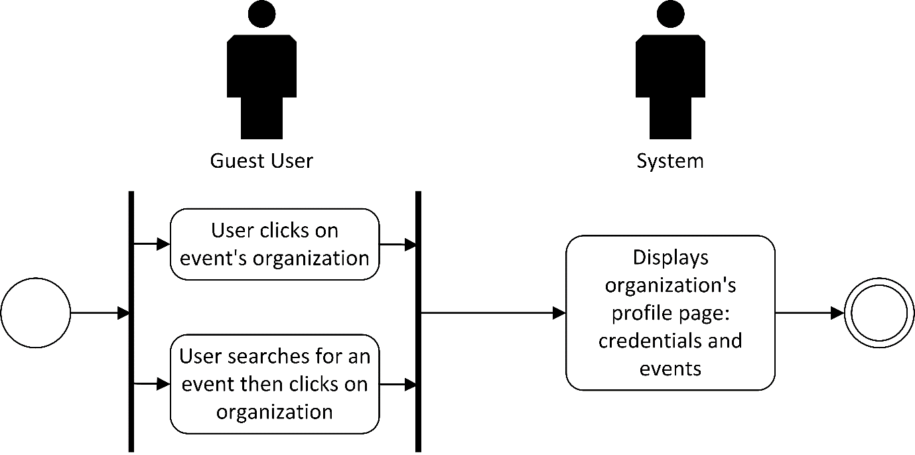

Post-conditions: Successful: The Eventi system successfully showed the organization and its details and events.
Failed: The website did not load.

Special Requirements: NONE

